**Tay Ren Yuan (27) Screenshot of the Project**

logcall.php (“Blank Page”) you have to Enter all the Required Details in the Correct Format.

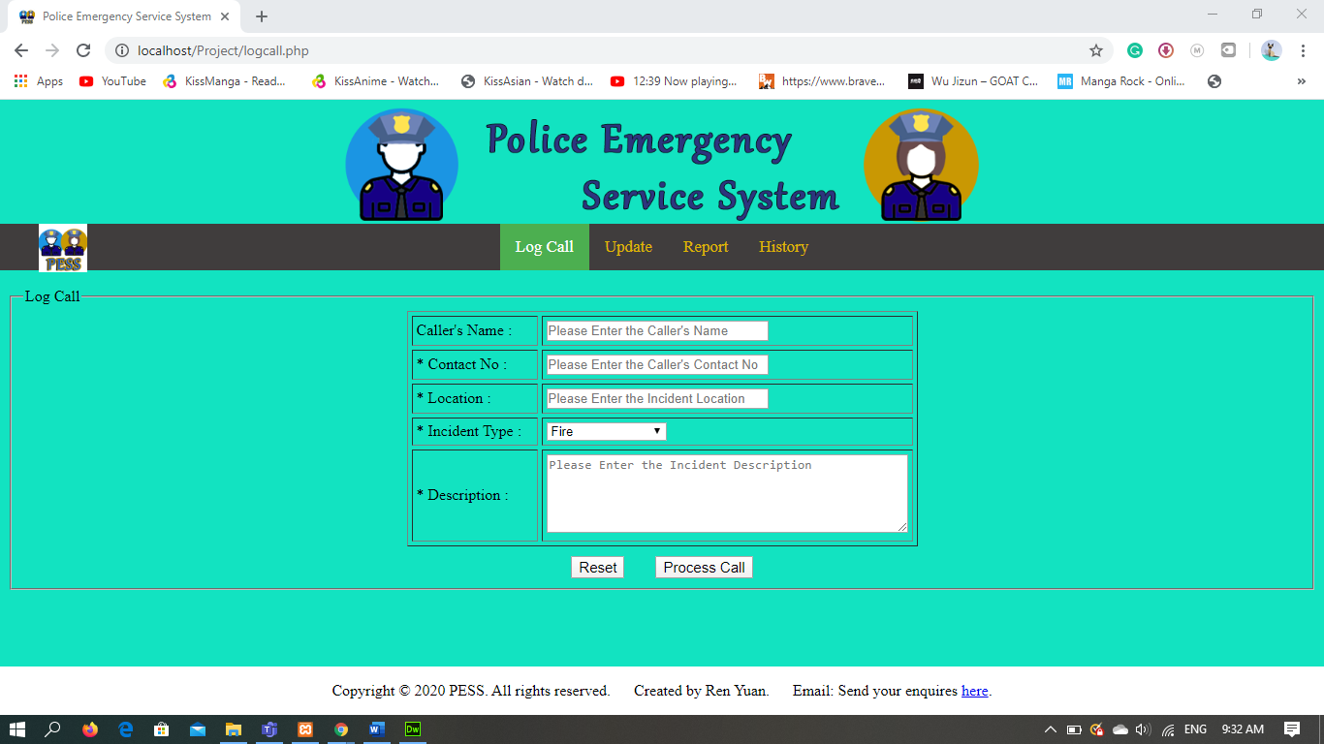

For the **Caller’s Name** Textbox, it is not a Required Field but it only allows Letters no Numbers and Special Characters. The Error Message is * Letters Only!. It has a placeholder: Please Enter the Caller's Name

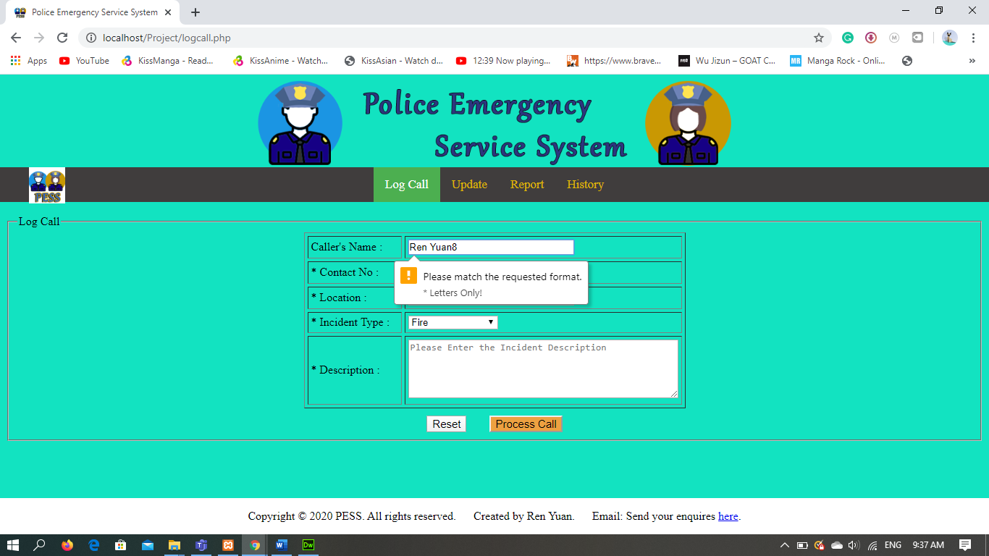

For the **Contact Number** Textbox, it is a Required Field indicated by the asterisk beside the name and it only allows Numbers that is between 60000000 to 99999999. The Error Message is Contact Number is incorrect! || Please re-enter a 8 Digital Numbers again. || *The Number must start with 6-9!. It has a placeholder: Please Enter the Caller's Contact No.

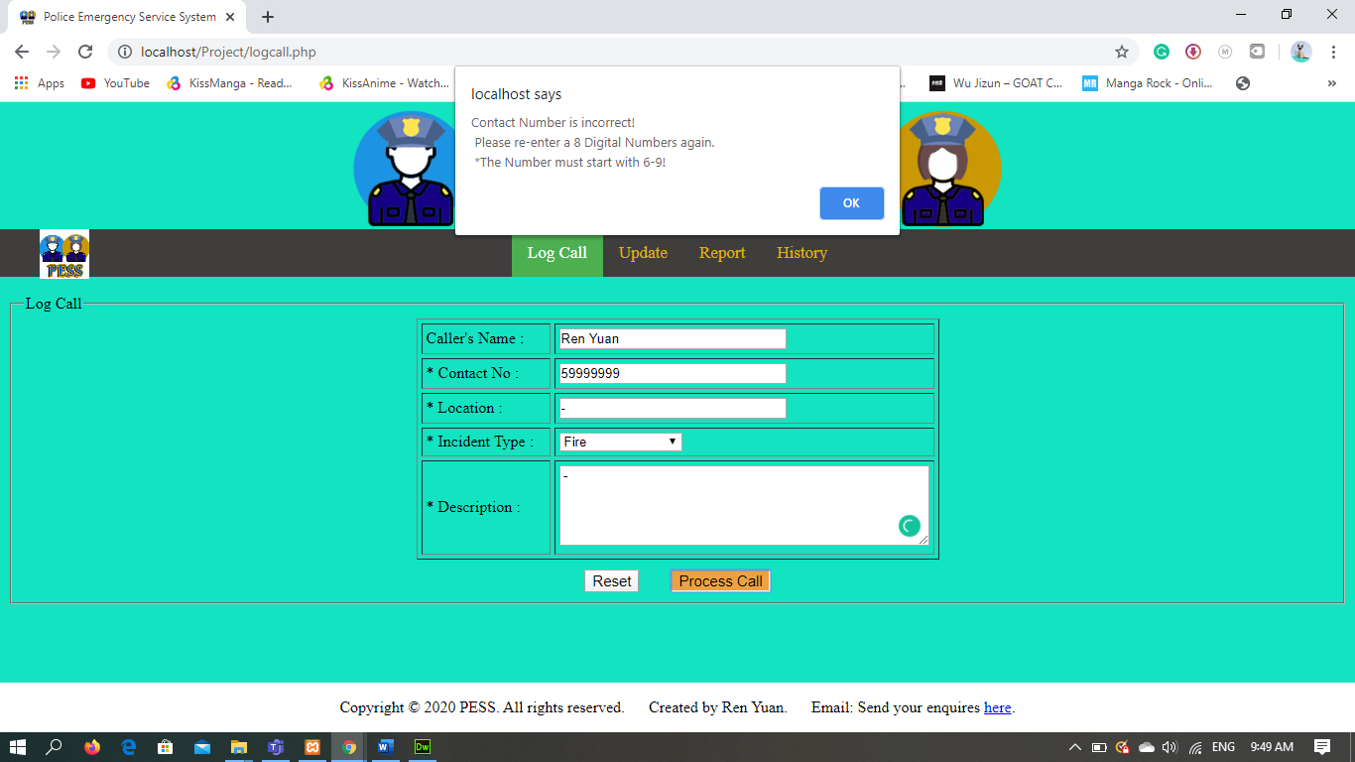

For the **Location** Textbox, it is a Required Field indicated by the asterisk beside the name and it doesn’t any special format. The Error Message is Please fill out this field. It has a placeholder: Please Enter the Incident Location.

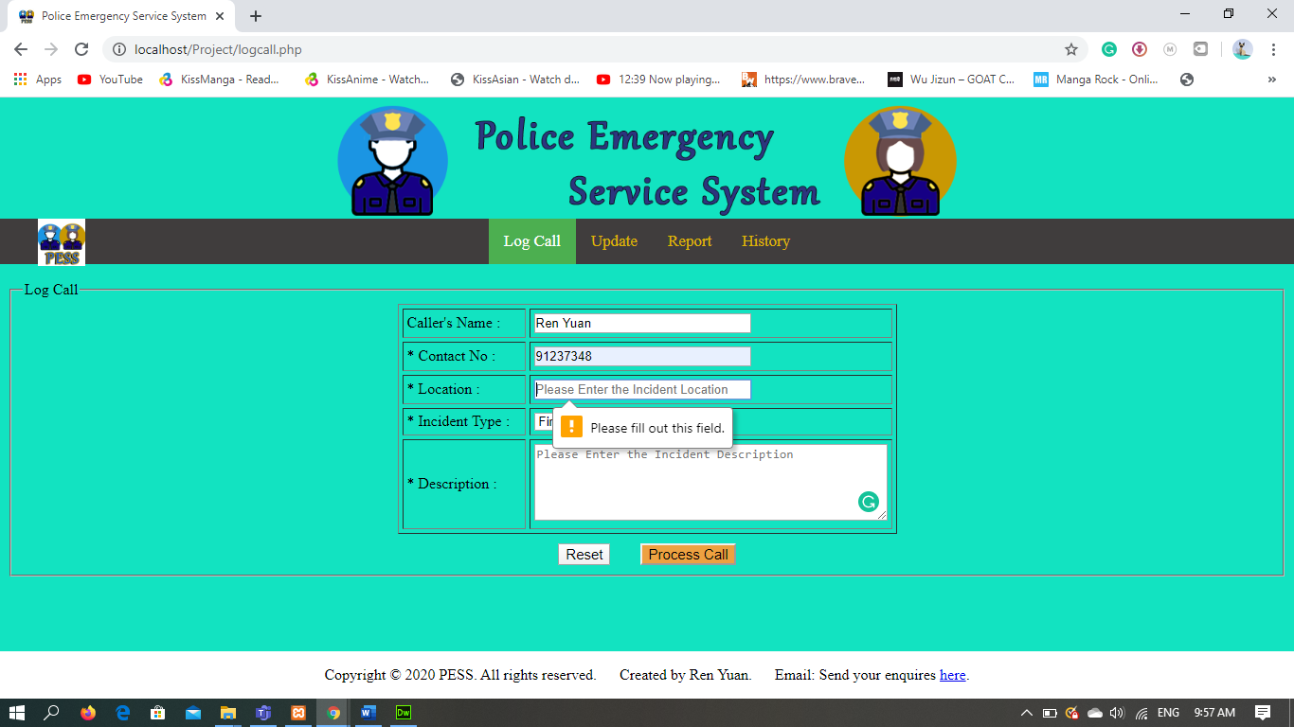

For the **Incident Type** Drop-Down List, it is a Required Field indicated by the asterisk beside the name and You have to select one of the choices. There is no Error. It has a placeholder: Fire.

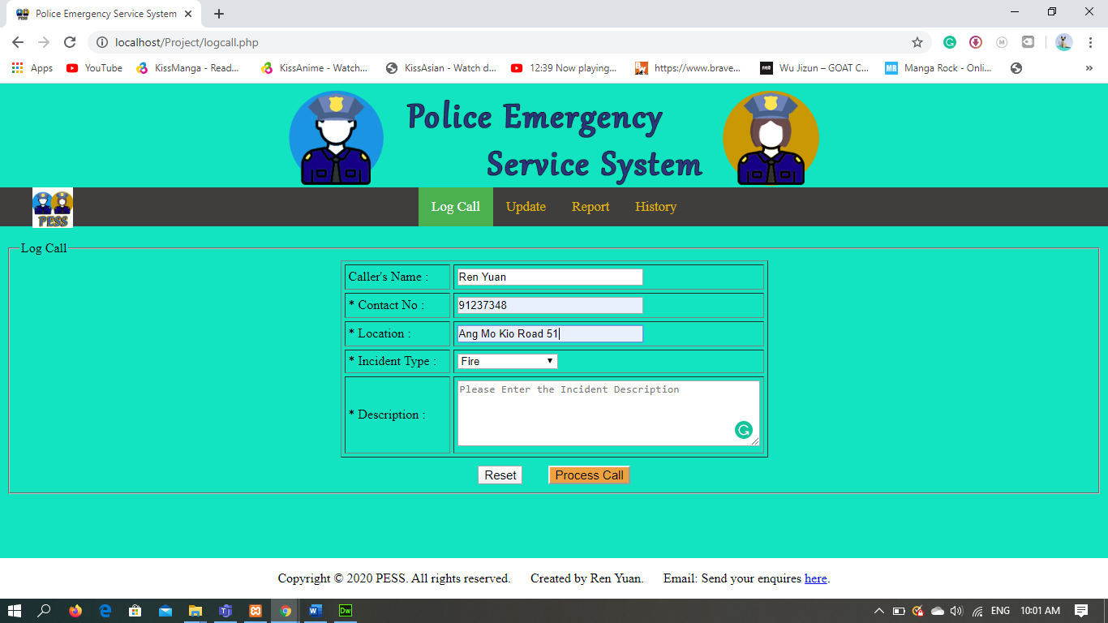

For the **Description** Textarea, it is a Required Field indicated by the asterisk beside the name and it doesn’t any special format. The Error Message is Please fill out this field. It has a placeholder: Please Enter the Incident Description.

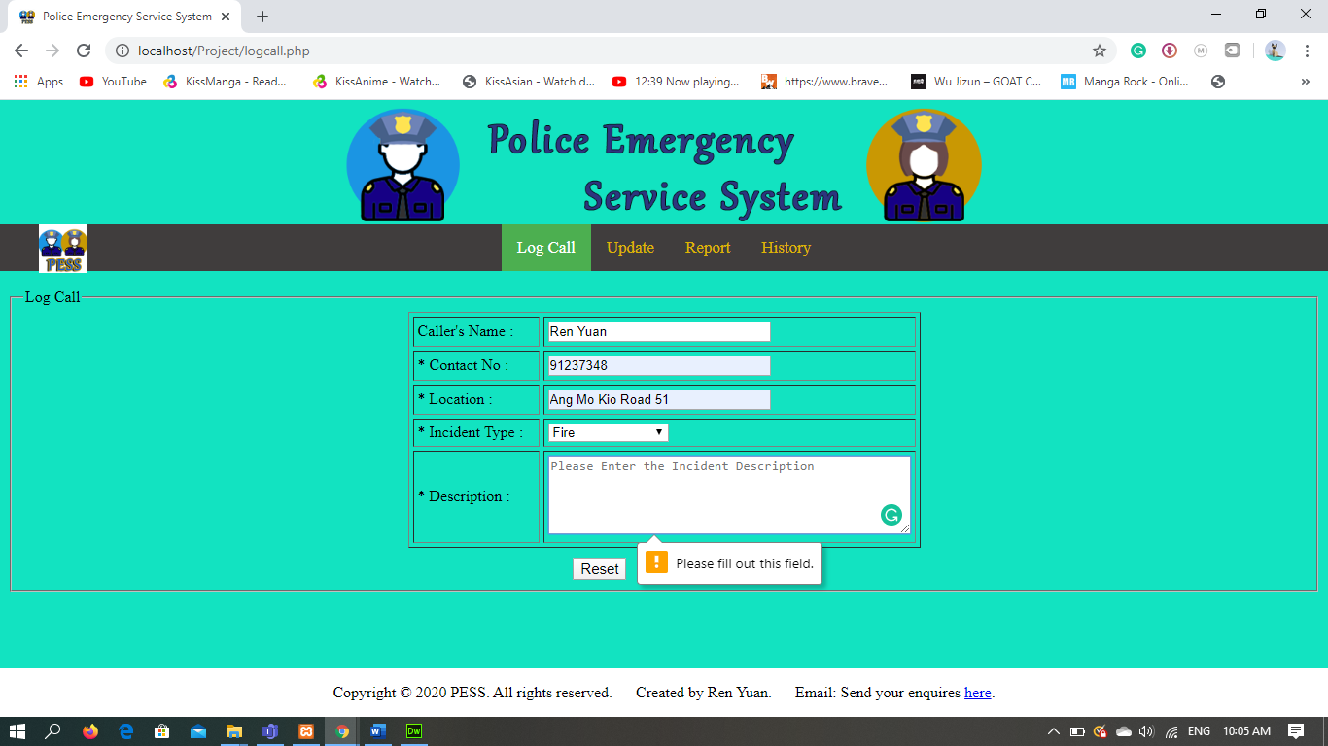

dispatch.php (“Blank Page”) you have to determined the uniqueness of the Call. Then tick the checkbox beside the Patrol Car ID that you wanted to dispatch which is either Free or on Patrol

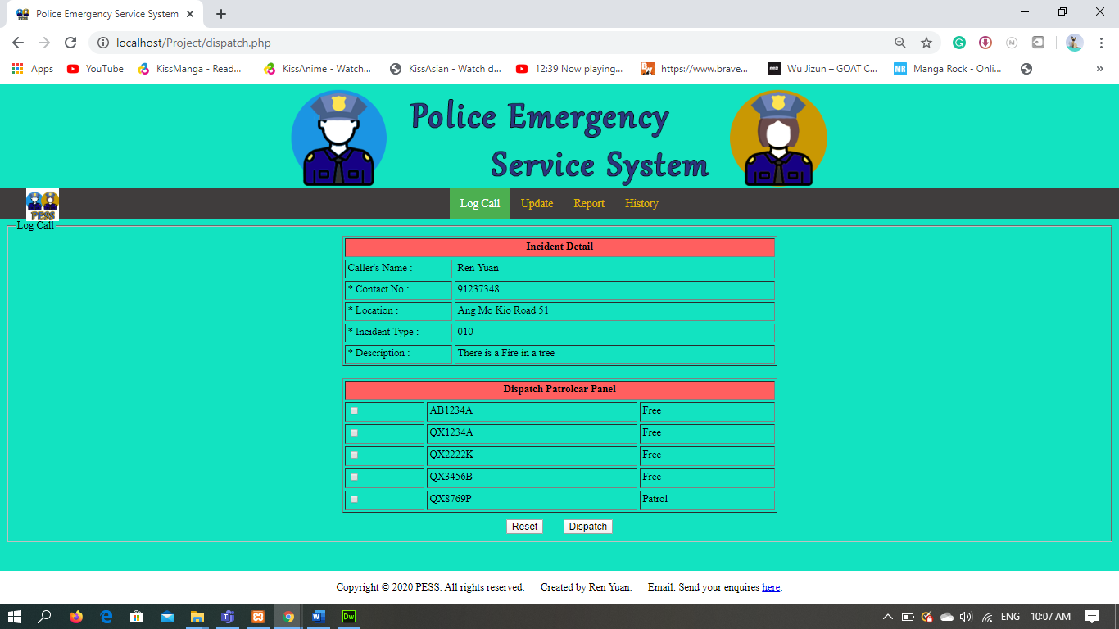

Before I dispatch the patrol car I will show you the localhost/phpMyAdmin (“Blank dispatch Browse”)

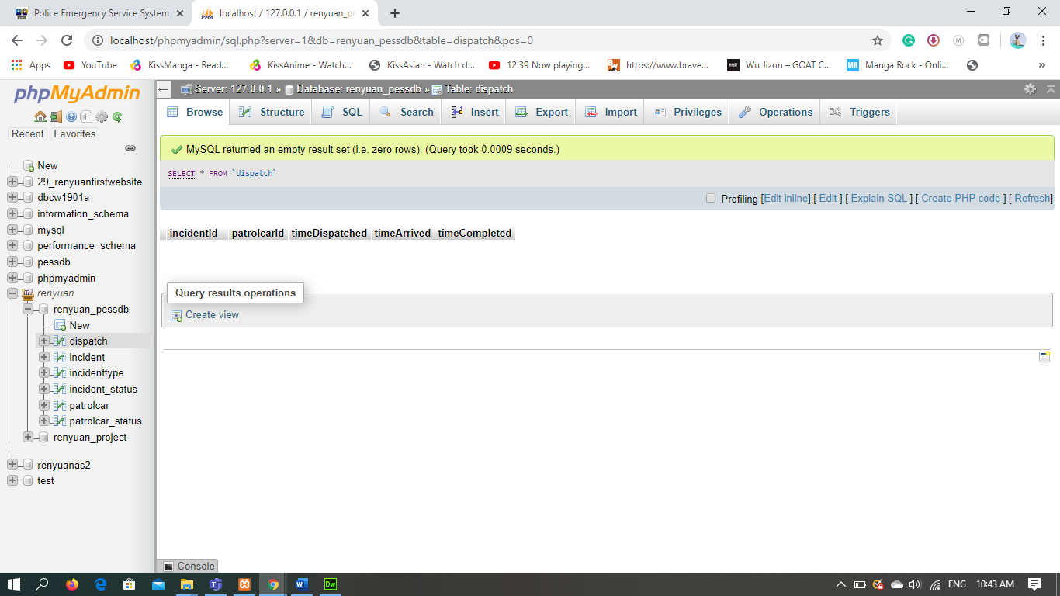

localhost/phpMyAdmin (“Blank incident Browse”)

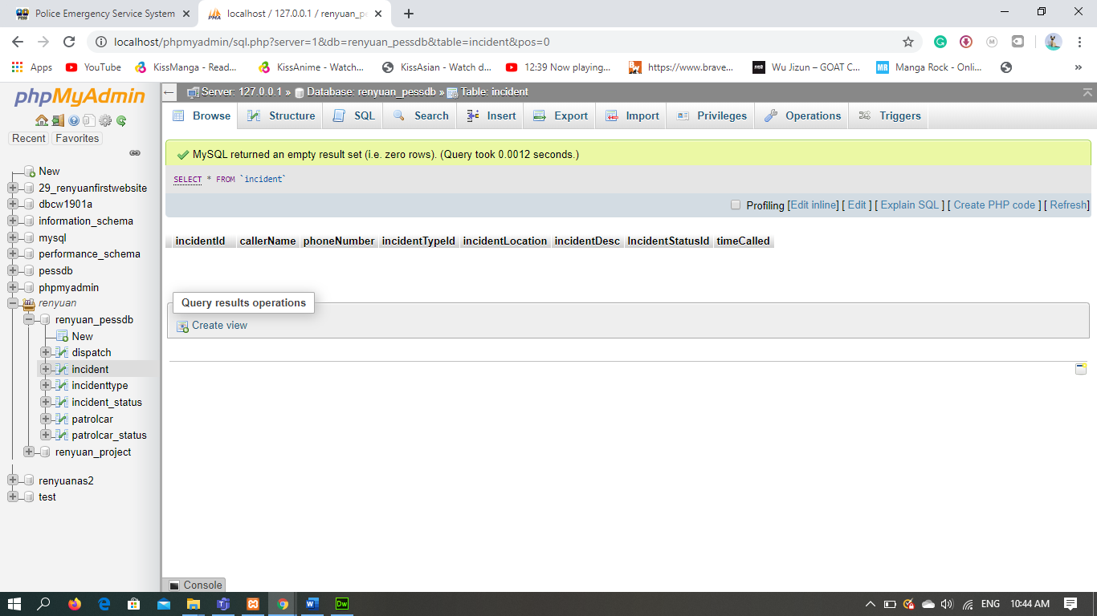

localhost/phpMyAdmin (“patrolcar Browse”) I will be choosing Patrol Car “AB1234A”

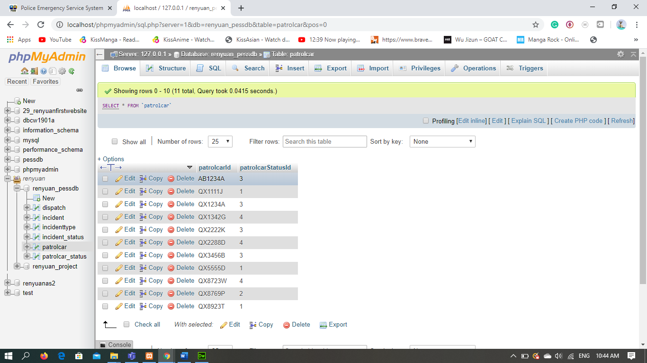

To dispatch the Patrol Car simply Tick the Checkbox that is beside the Patrol Car you want to dispatch. I will be choosing Patrol Car “AB1234A”

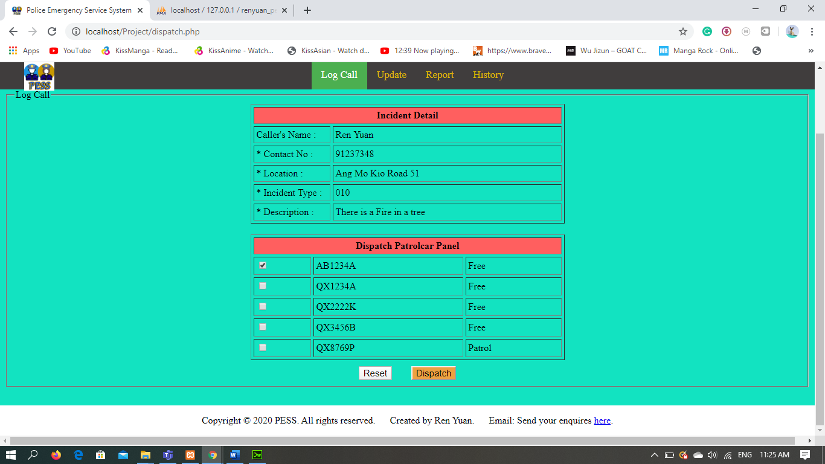

The Row with the Patrol car ID of “AB1234A” have disappear as it is currently on dispatch

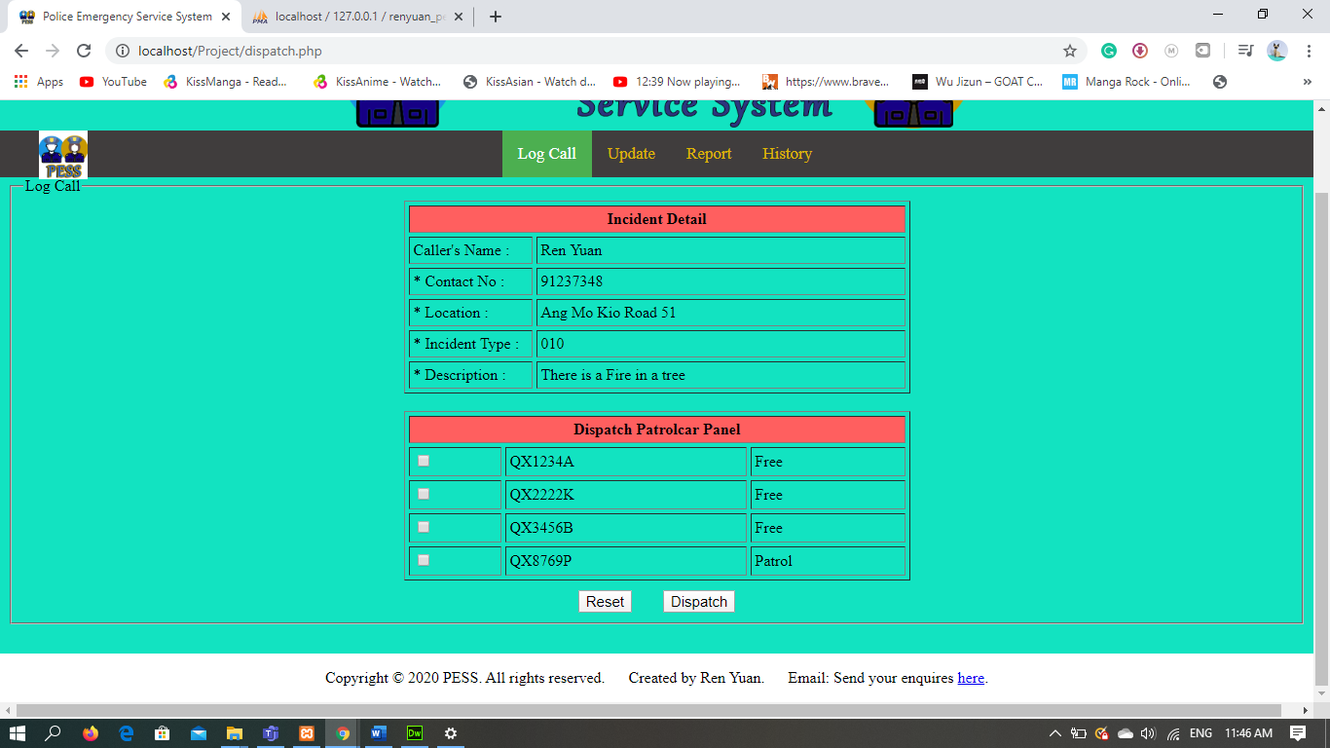

localhost/phpMyAdmin. Under the dispatch section below the column timeDispatched the time when I dispatch the Patrol Car have appear.

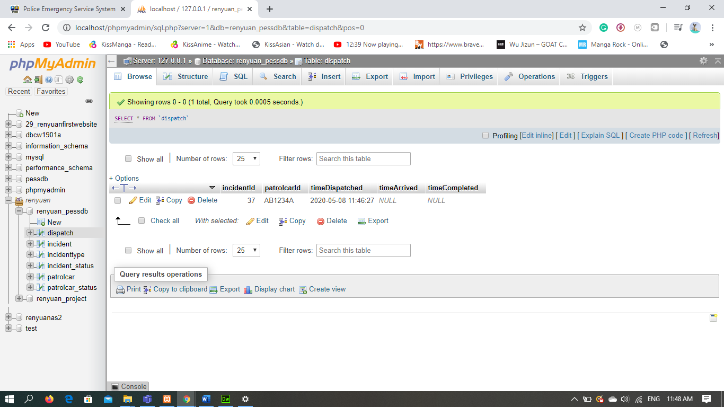

localhost/phpMyAdmin. Under the incident section the details of the call have appear

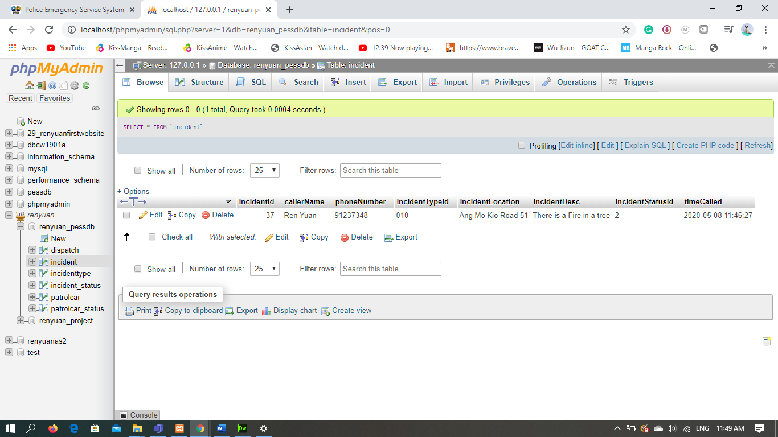

localhost/phpMyAdmin. Under the patrolcar section below the column patrolcarStatusId the Patrol Car Status have changes to 1. I have chosen Patrol Car “AB1234A”.

1= Dispatched, 2= Patrol, 3=Free, 4= Arrived

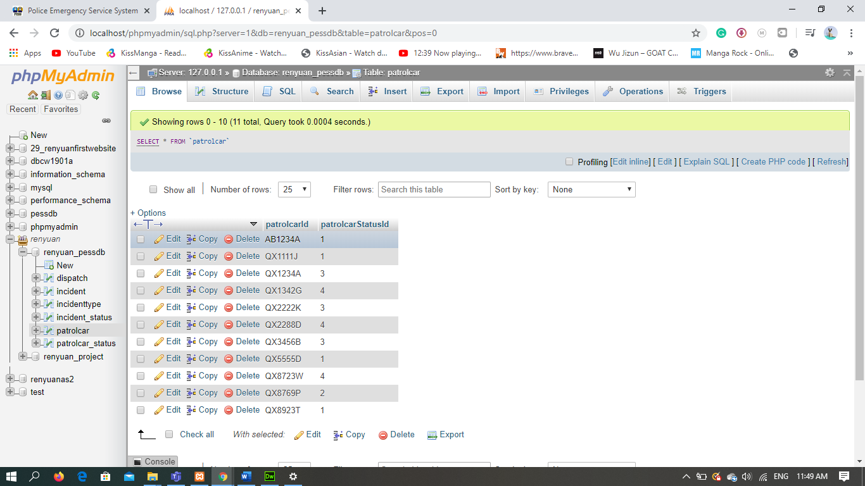

update.php (“Blank Page”) You have to enter the Patrol Car ID of a particular Patrol Car You wants to change. (In this case I will enter “AB1234A”)

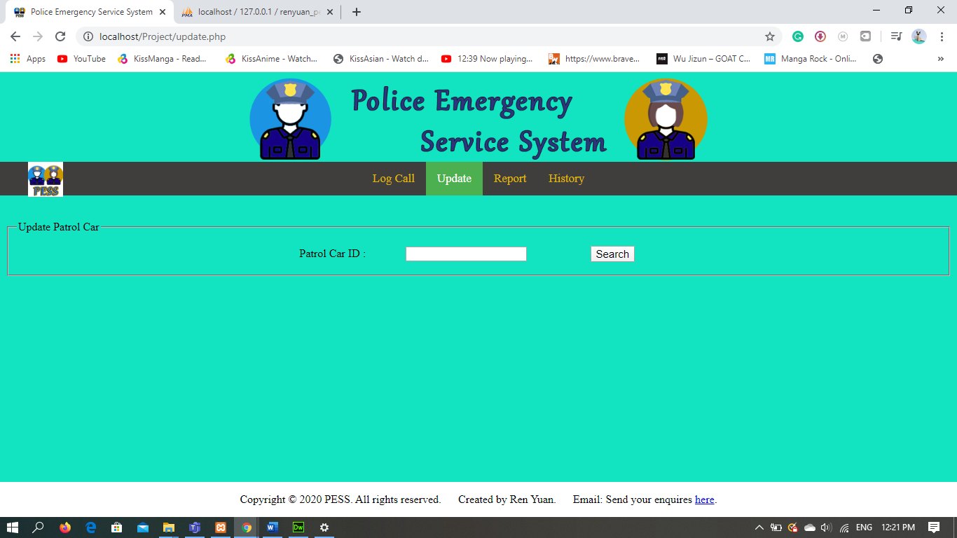

If you Enter the wrong Patrol Car ID that does not exist in the server you will come to this loading page with the error messages: The Patrol Car ID is Incorrect! || Please re-enter the Patrol Car ID again.

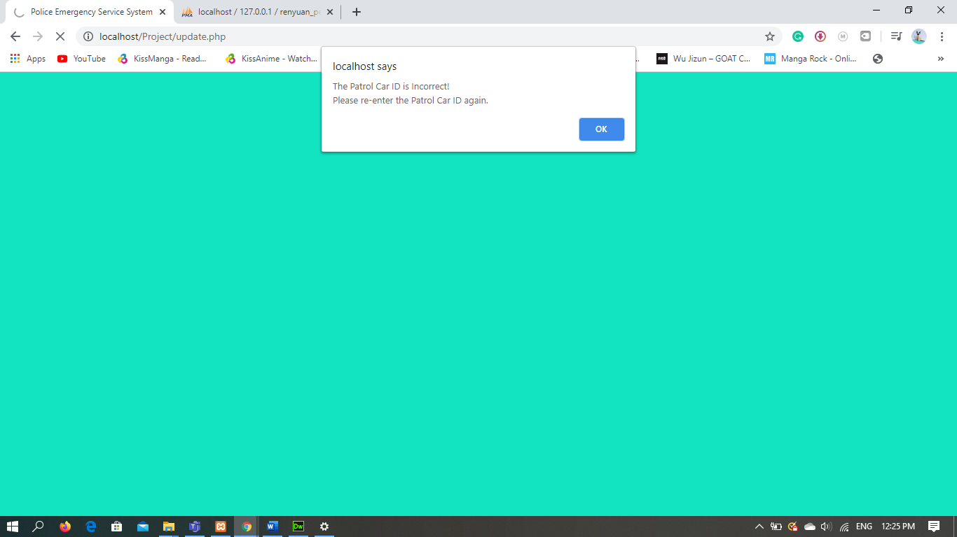

After you enter the correct Patrol Car ID you will see a new table. The Status Row will show the Current info from the databased (in this case it is Dispatched)

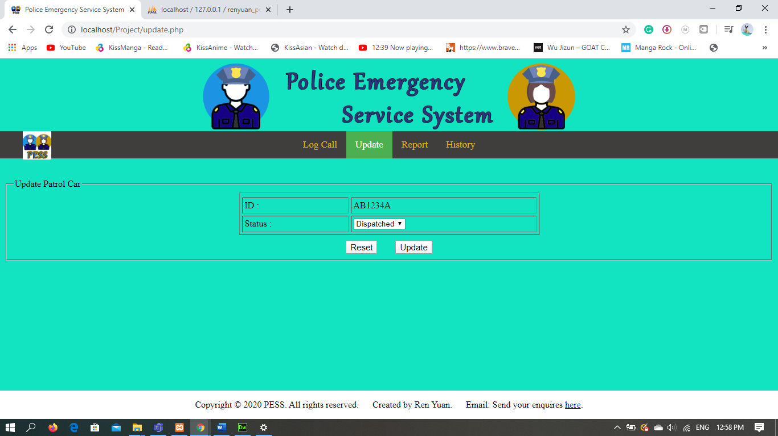

To change the status, click on the drop-down list and select the correct status. (In this case I will select the Arrived)

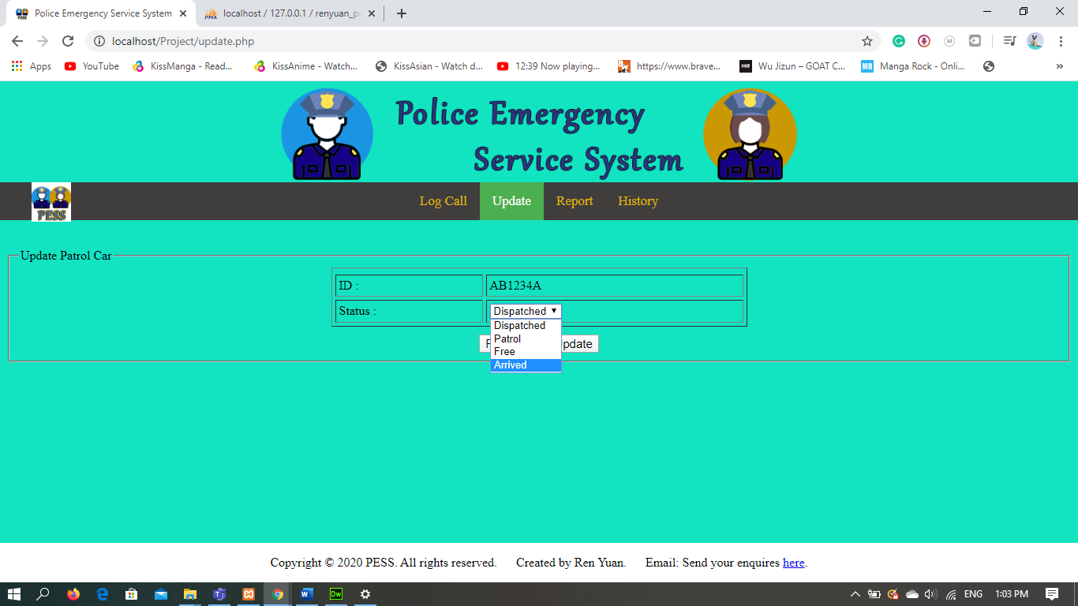

localhost/phpMyAdmin. Under the dispatch section below the column timeArrived the time when the Patrol Car reach the scene have appear.

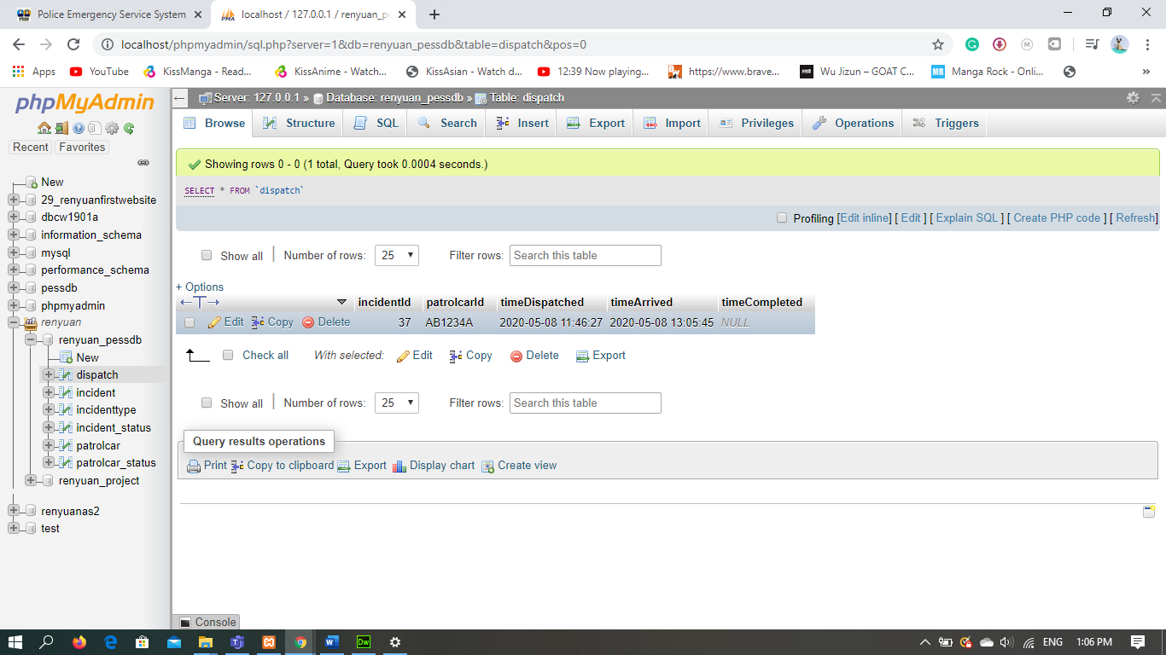

localhost/phpMyAdmin. Under the incident section the details of the call remain the same.

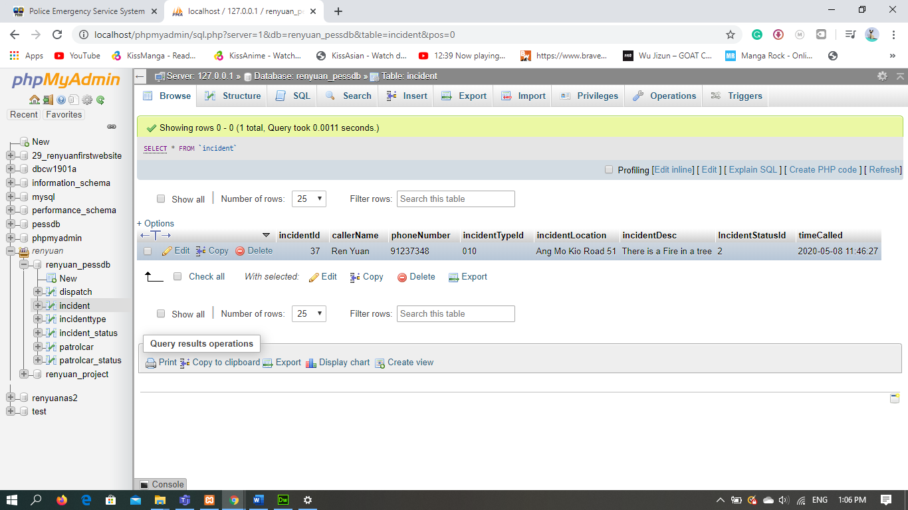

localhost/phpMyAdmin. Under the patrolcar section below the column patrolcarStatusId the Patrol Car Status have changes to 4. I have chosen Patrol Car “AB1234A”.

1= Dispatched, 2= Patrol, 3=Free, 4= Arrived

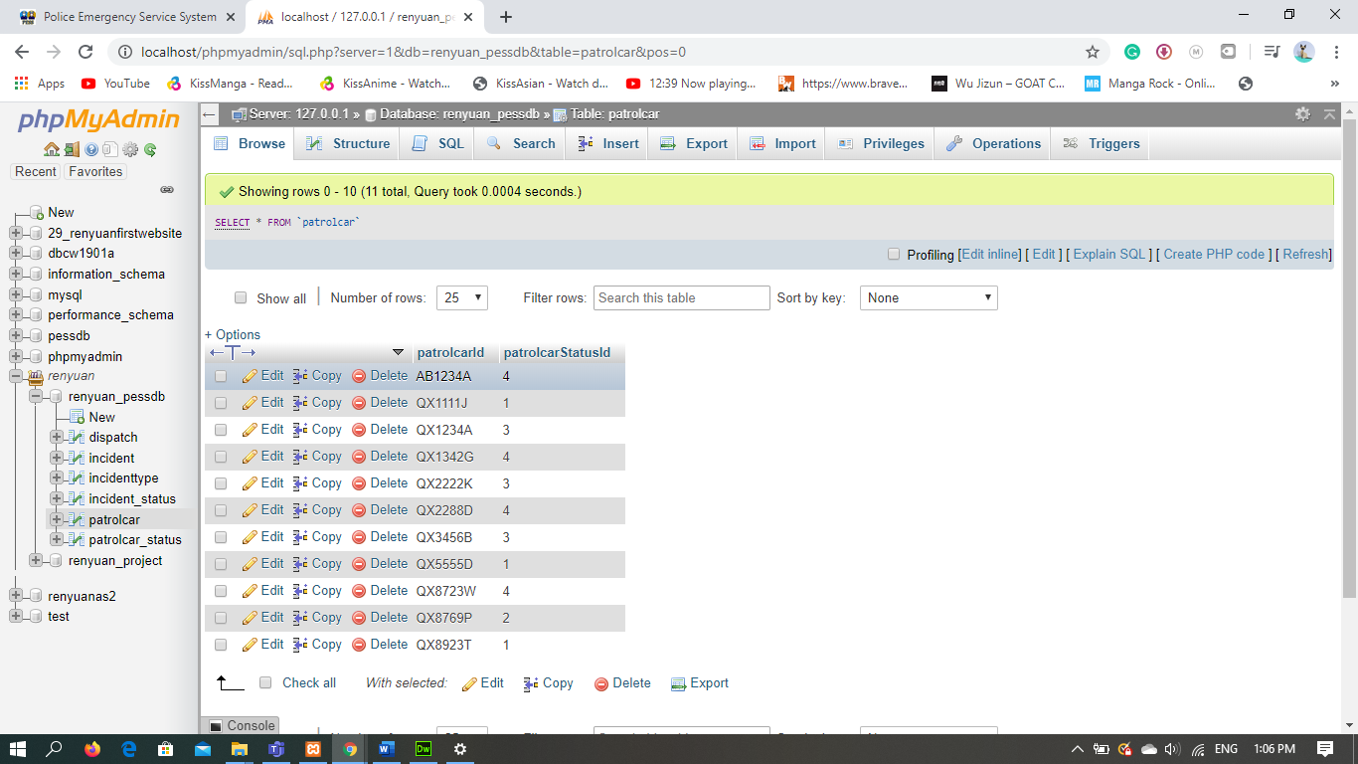

update.php. When the Patrol Car have finish with the incident, we need to update the status again to “FREE”

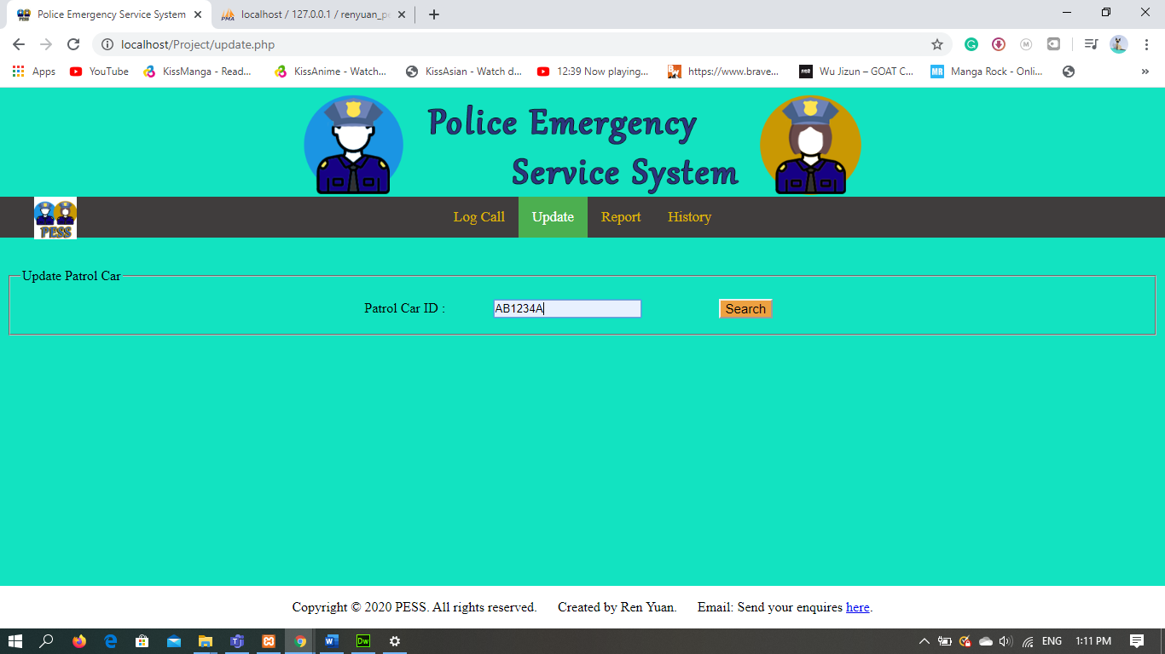

After you enter the correct Patrol Car ID you will see a new table. The Status Row will show the Current info from the databased (in this case it is Arrived).

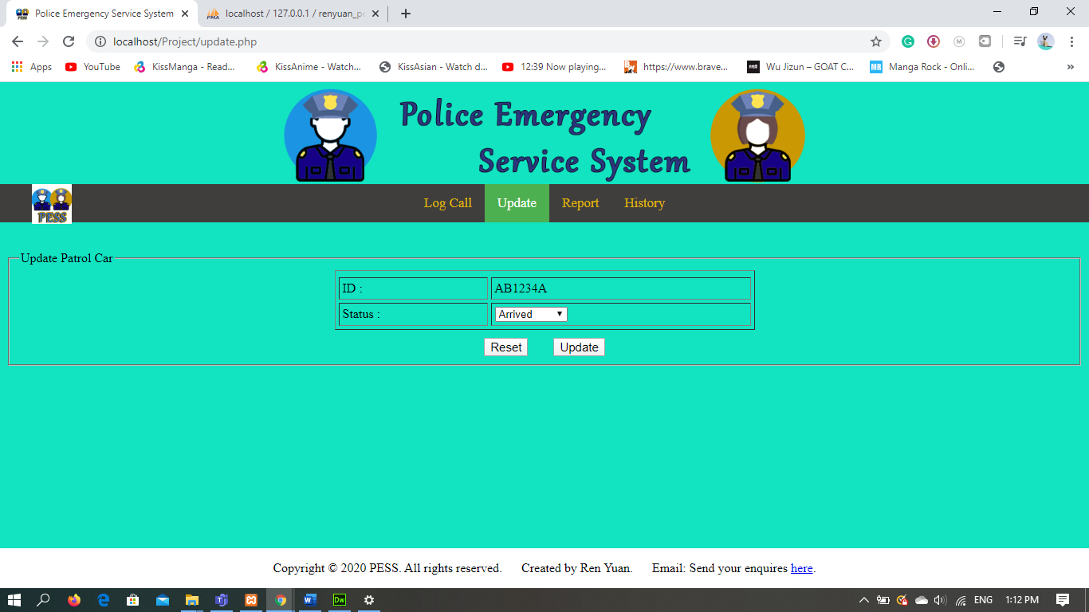

To change the status, click on the drop-down list and select the correct status. (In this case I will select the FREE)

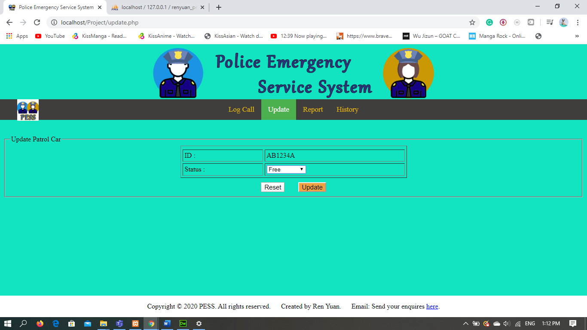

localhost/phpMyAdmin. Under the dispatch section below the column timeCompleted the time when the Patrol Car have finish with the incident have appear.

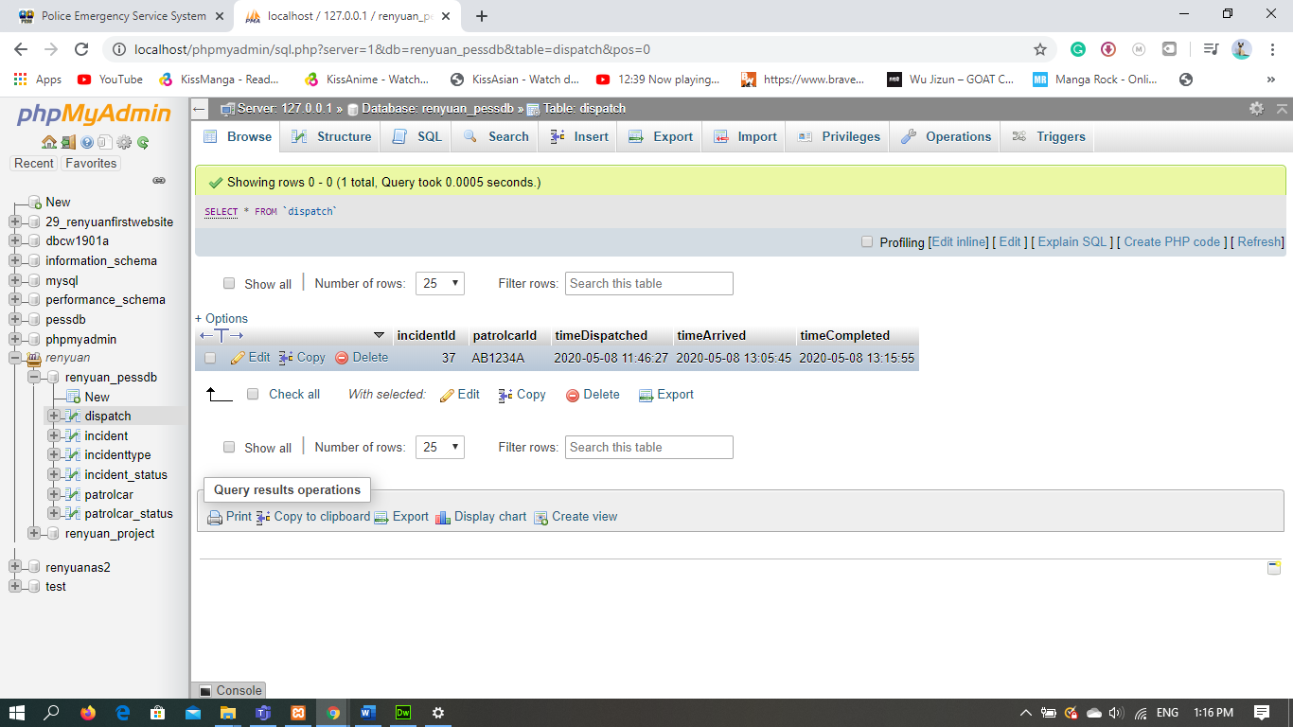

localhost/phpMyAdmin. Under the incident section the details of the call remain the same.

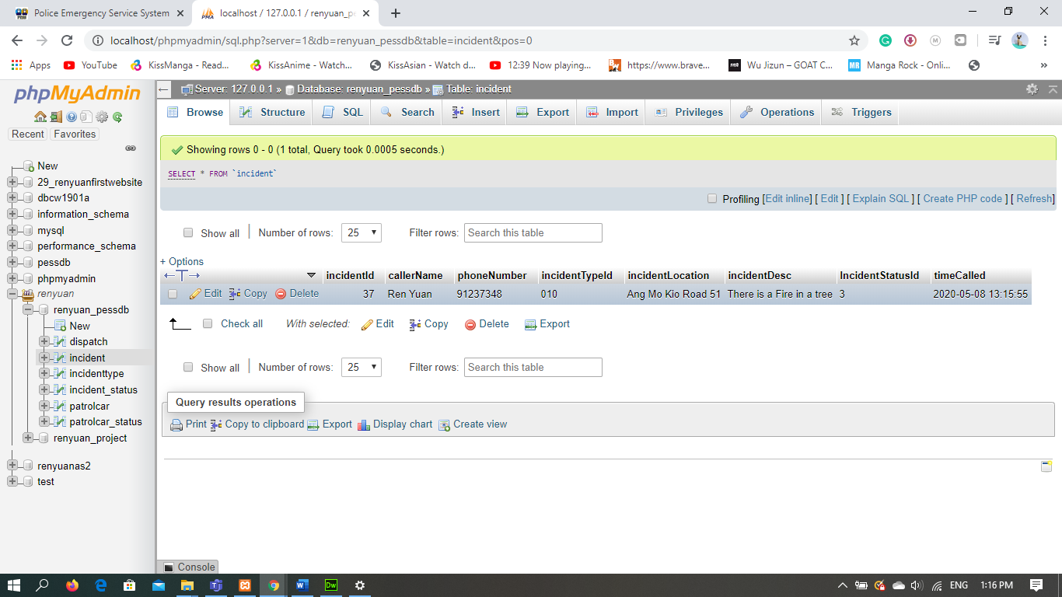

localhost/phpMyAdmin. Under the patrolcar section below the column patrolcarStatusId the Patrol Car Status have changes to 3. I have chosen Patrol Car “AB1234A”.

1= Dispatched, 2= Patrol, 3=Free, 4= Arrived

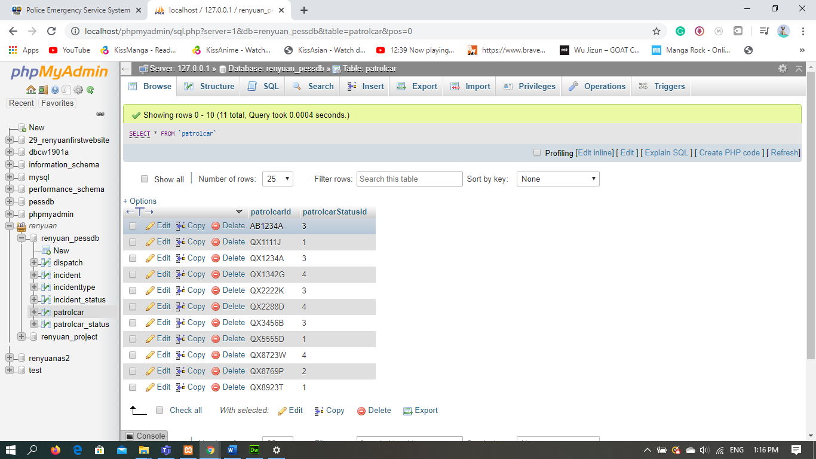

**Screenshot localhost/phpMyAdmin.**

renyuan_pessdb (structure)

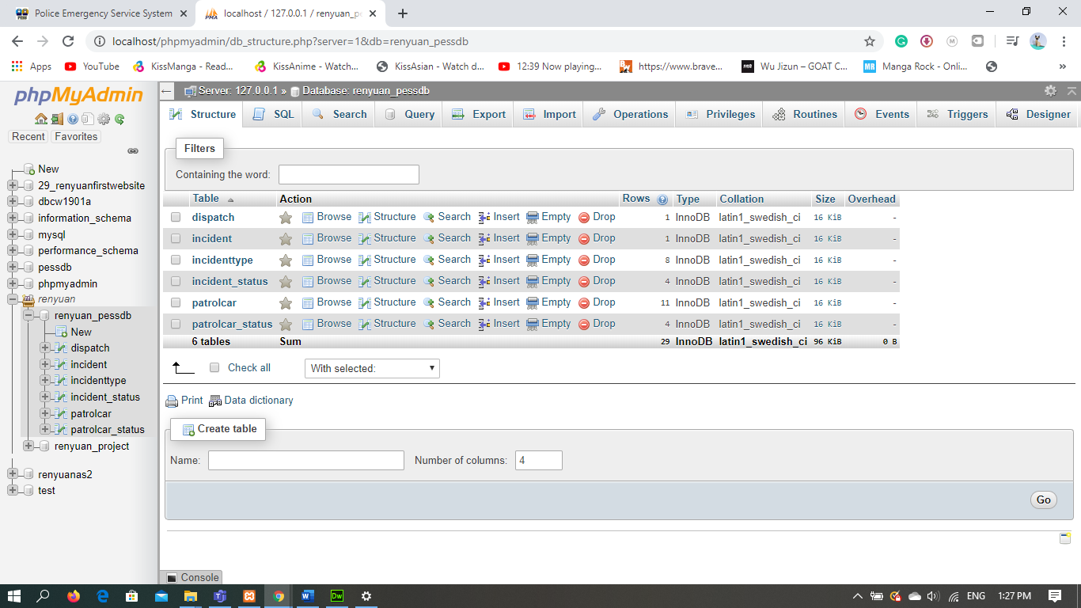

dispatch (Browse)

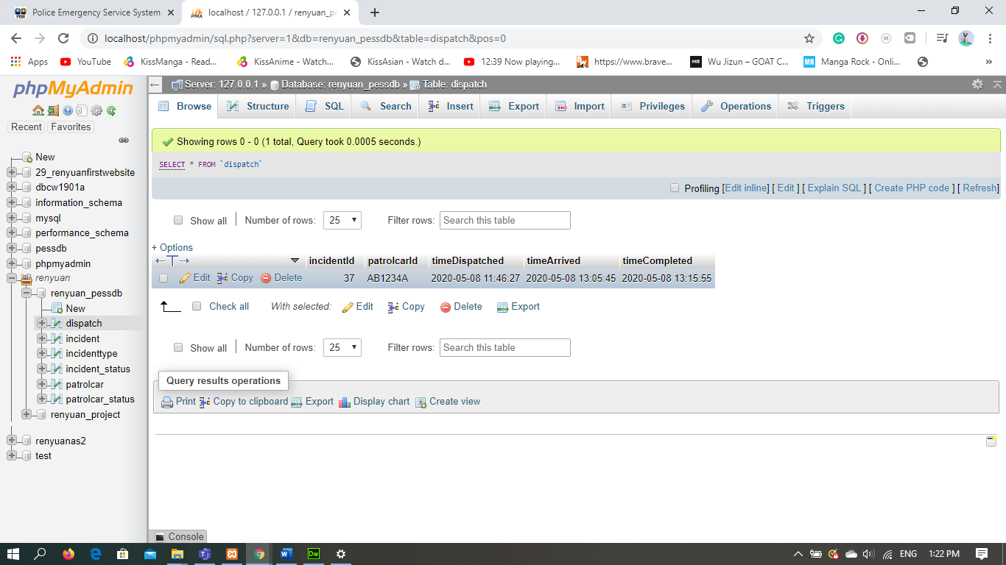

dispatch (structure)

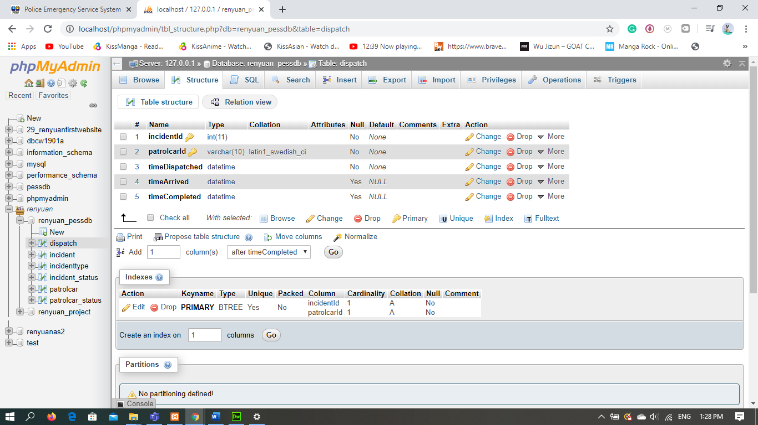

incident (Browse)

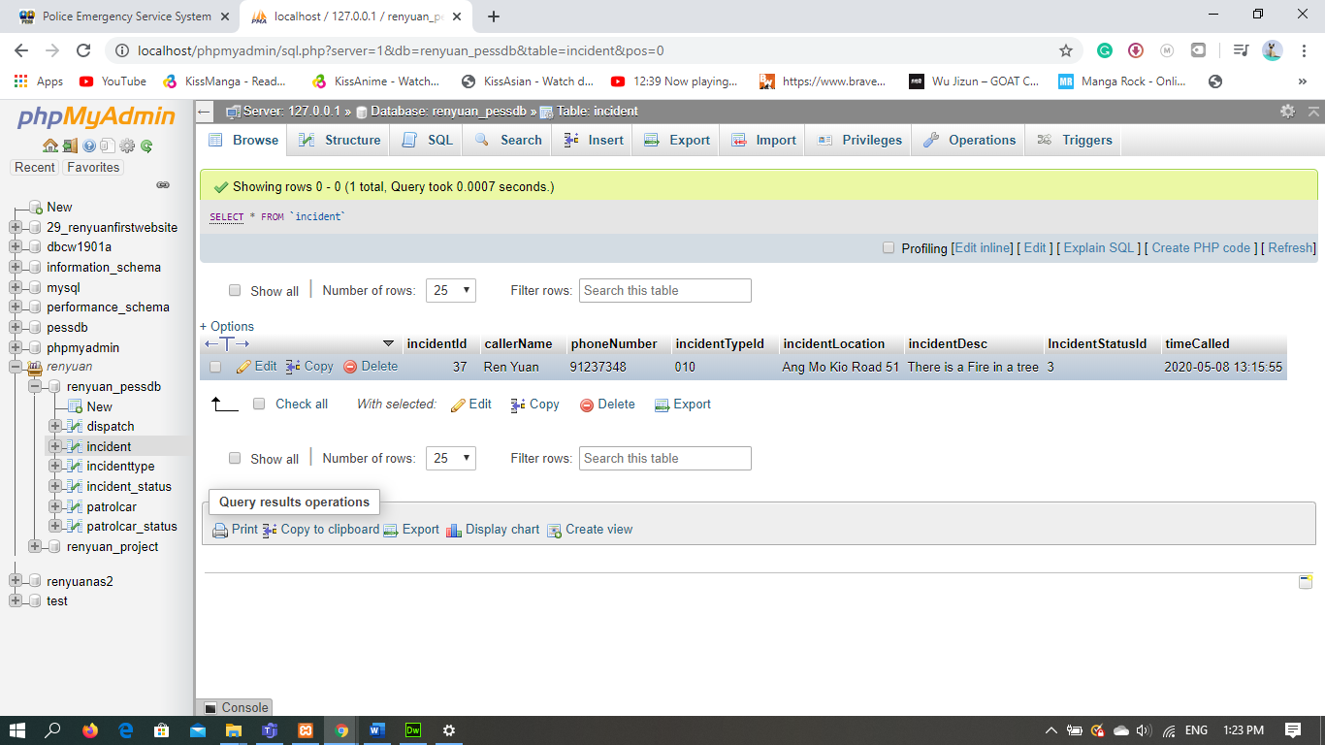

incident (structure)

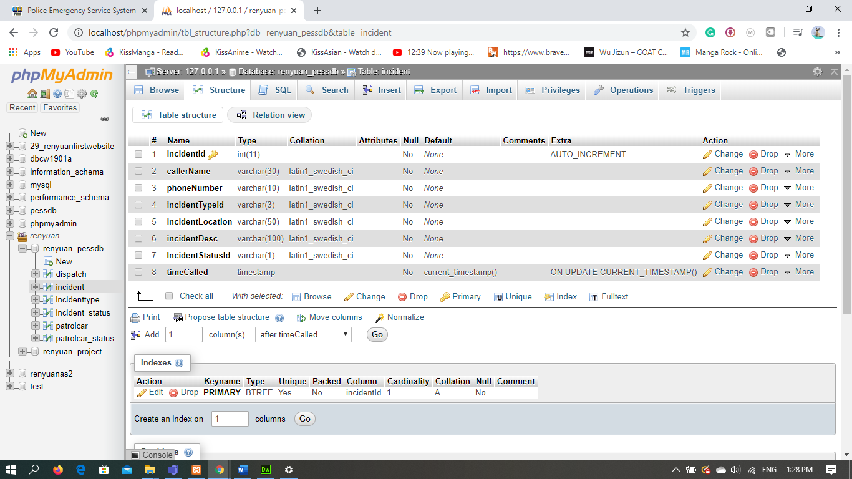

incidenttype (Browse)

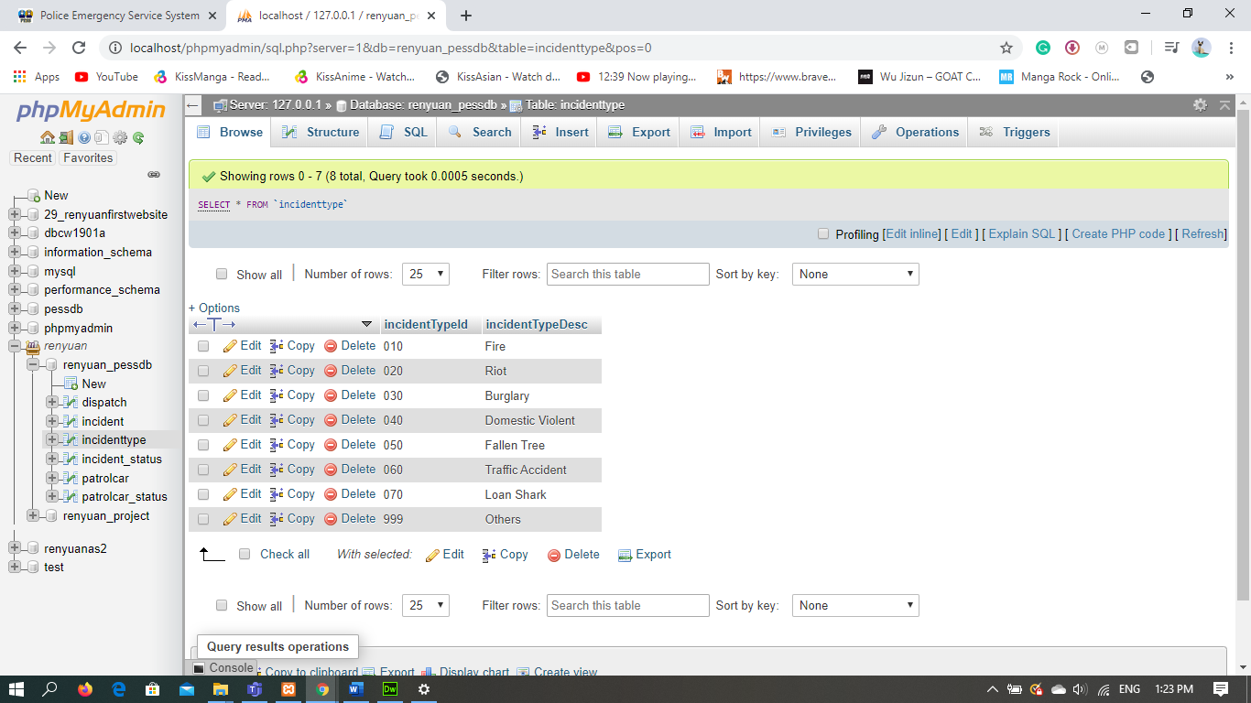

incidenttype (structure)

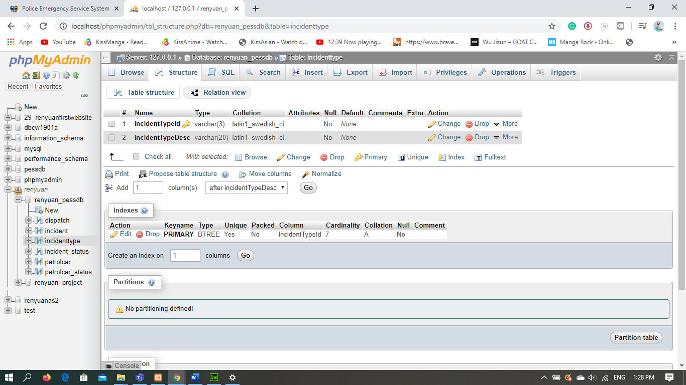

incident_status (Browse)

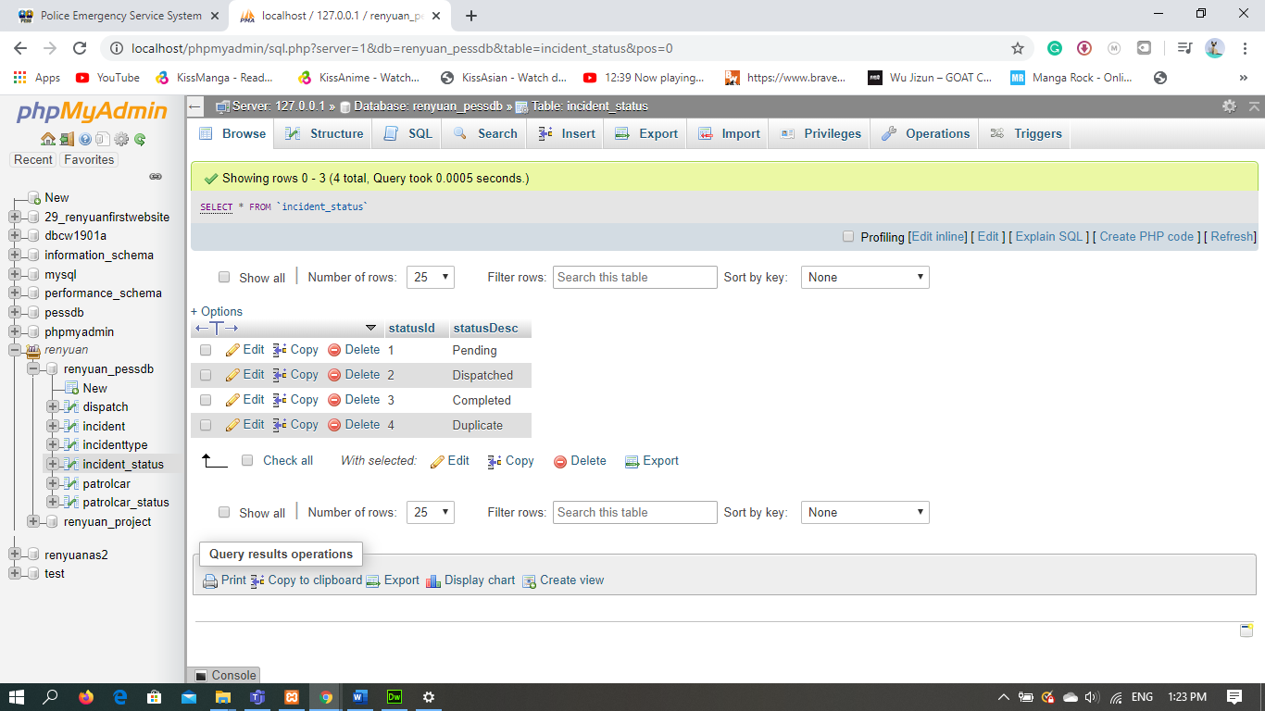

incident_status (structure)

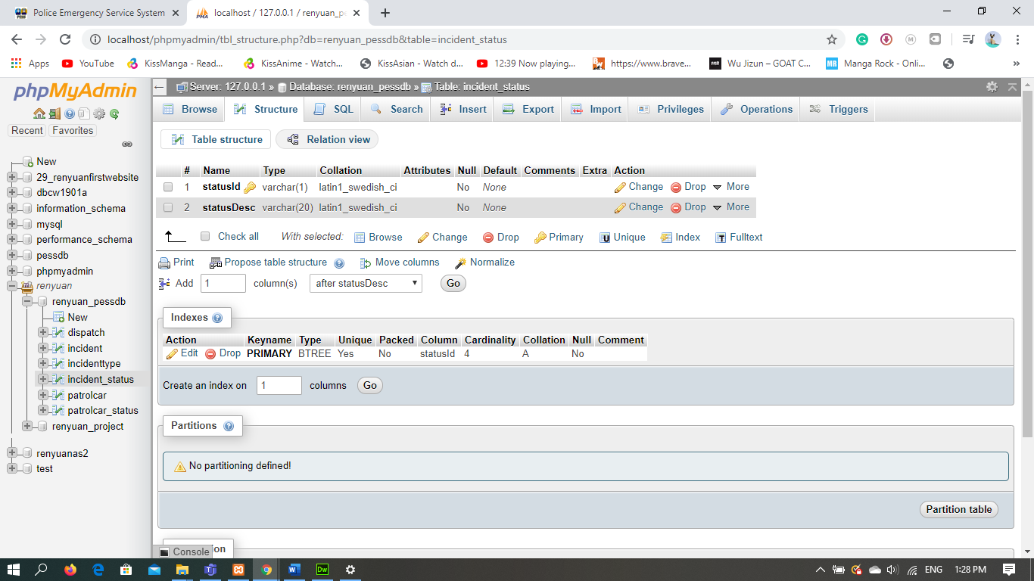

patrolcar (Browse)

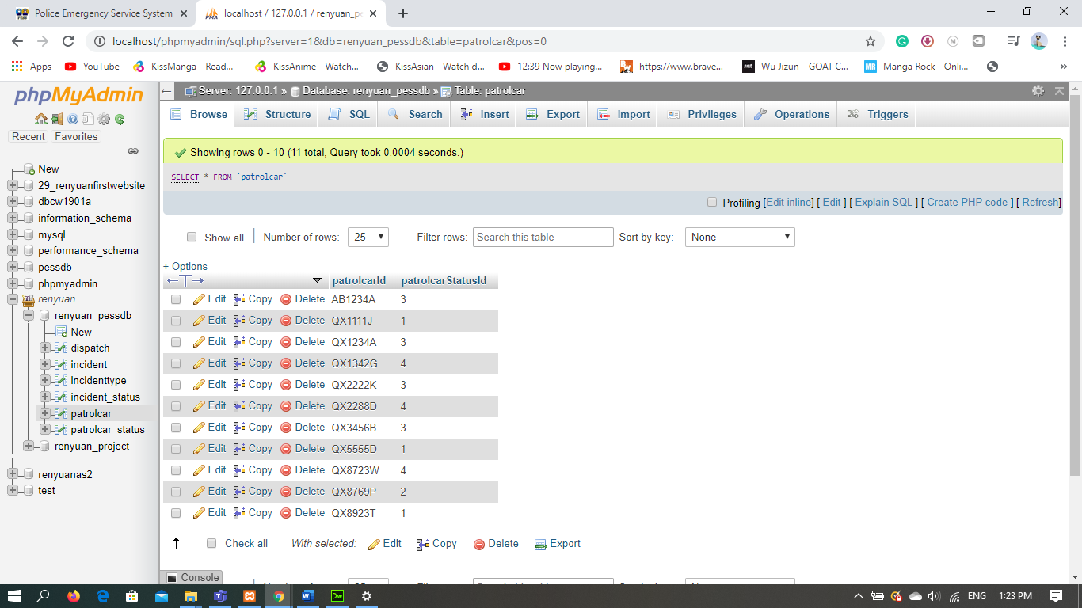

patrolcar (structure)

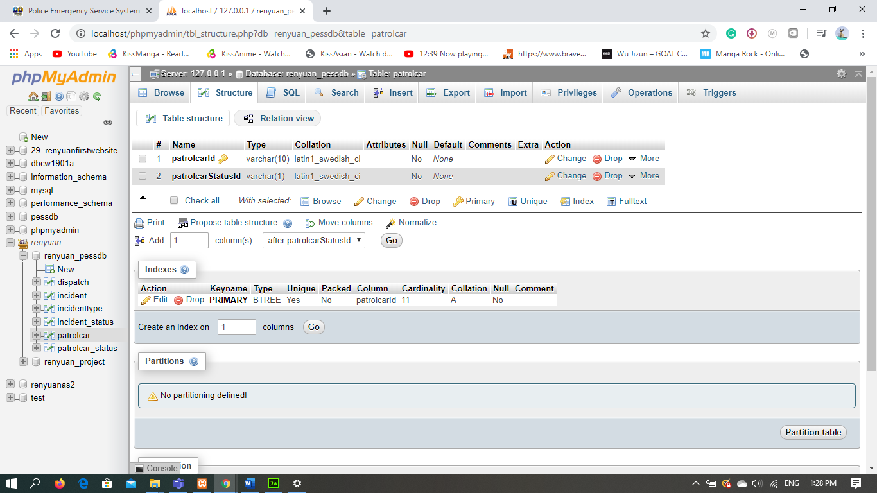

patrolcar_status (Browse)

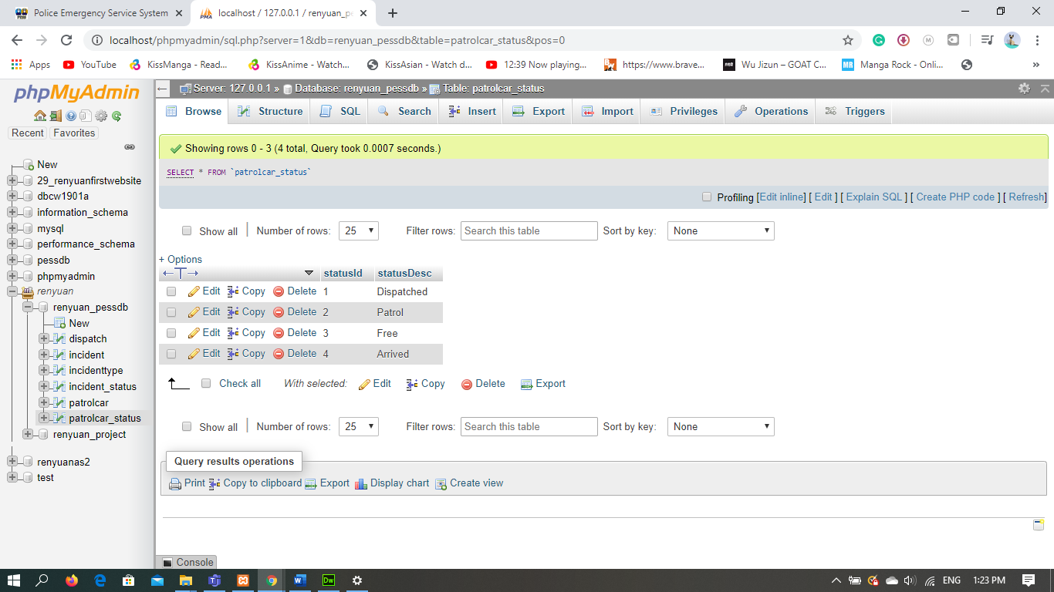

patrolcar_status (structure)

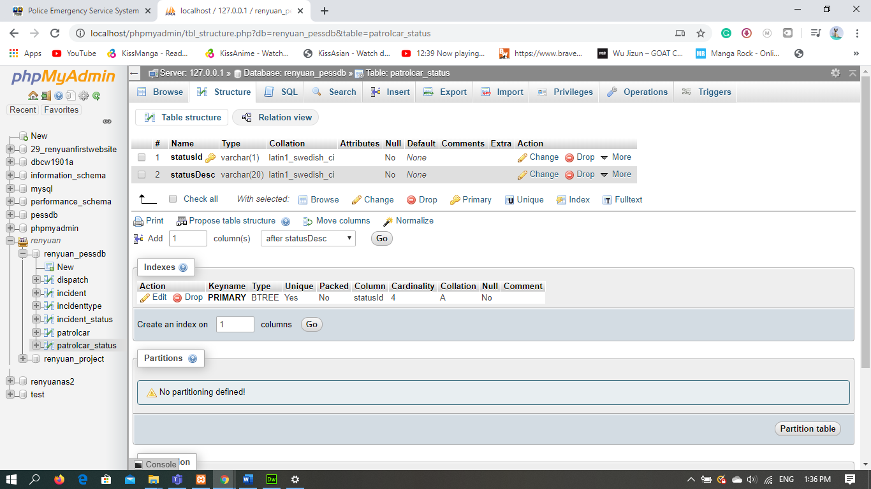

File locations

